ADVENTURES IN FUNCTION CRAFT!

Today we are going to discuss functions. Functions in javaScript or any language can be a bit confusing . I am going to try to put this in MINECRAFT terms for us all to keep track of.

A Function is like a crafting table in minecraft. We put things in the crafting table and out pops something new. Functions do not have to pop up something new, they can just do a specific tasks. Just like a factory has different machines on an assembly line our code has different methods to do different tasks. Let us think about this in terms of the beloved minecraft crafting table.

When we want to make something in minecraft we make a crafting table. We need to make our function in order for us to be able to use it to craft or execute our code. So let us do that below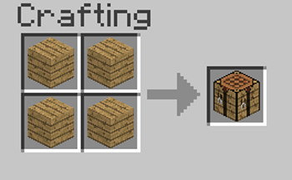

function craftingTable()

{

}

This is just like making our crafting table in minecraft. We created our function and now we decide the recipe for our crafting table. Our crafting table sadly can make only 1 thing ,so we need to decided what goes into the table and what we want out.

Now we have our crafting table!!! We need to put materials or in code language PARAMETERS into the table so we can make something.

If you look at our function craftingTable() the parentheses or the “()” are where we make the recipe for our crafting table to use to make what we want it to make. If I wanted to make a torch in minecraft I would need coal and sticks.



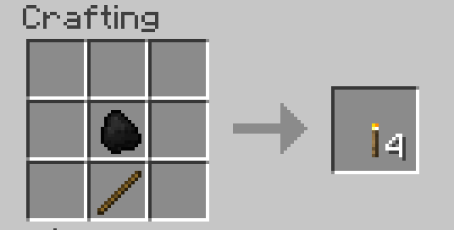

function craftingTable( stick , coal )

{

var fourTorches=coal+stick;

return fourTorches;

}

Now of course javaScript doesn’t understand coal and torches, but those would work as variable names in javaScript. It might of course be confusing...but you could use them. This function in JavaScript would actually just add up 2 numbers for you. If we wanted to add up ANY 2 numbers all we would need to do in our code is:

Var addedNumber=craftingTable(5,6);

The number 5 becomes the variable “stick” and the number 6 becomes the variable “coal”.We combine them into the variable” fourTorches” and then RETURN that value to the variable “addedNumber”.

Now “addedNumber” is equal to 11. If we ever wanted to we can even input our “addedNumber” into our craftingTable and add to it!

addedNumber=craftingTable(addedNumber,6);

The code above changes addedNumber to the original addedNumber. Our original number was 11. We added 6 to the value so addedNumber is now 17! You could do this as much as you like and continue to assign the value of “addNumber”. You could even do addedNumber=craftingTable(addedNumber,addedNumber); and change addedNumber to itself but doubled! In our case addedNumber would now equal 34.

The return statement spits out what we want the function to be equal to. In minecraft the table returns a torch. The function we made returns a number. Here is a link with more examples of return statements in java script: https://www.w3schools.com/jsref/jsref_return.asp

Code the challenge below to test your javascript knowledge.

Vending machine challenges. Each worth 3-5 tickets.

1. No 2 prices can be the same
2. No negative numbers
3. Randomly generate the amount of money you have. It has to be a minimum of the cheapest item you have.
4. Make it so the user can choose to either input the prices or have them randomly generate.
5. Create a new option called inventory that spits out what the user currently has.
6. Make it so the user can refund an item.
7. Ask and use the user's name in your prompts.
8. Research and use the window.close function to close the current window after your vending machine is done being used.